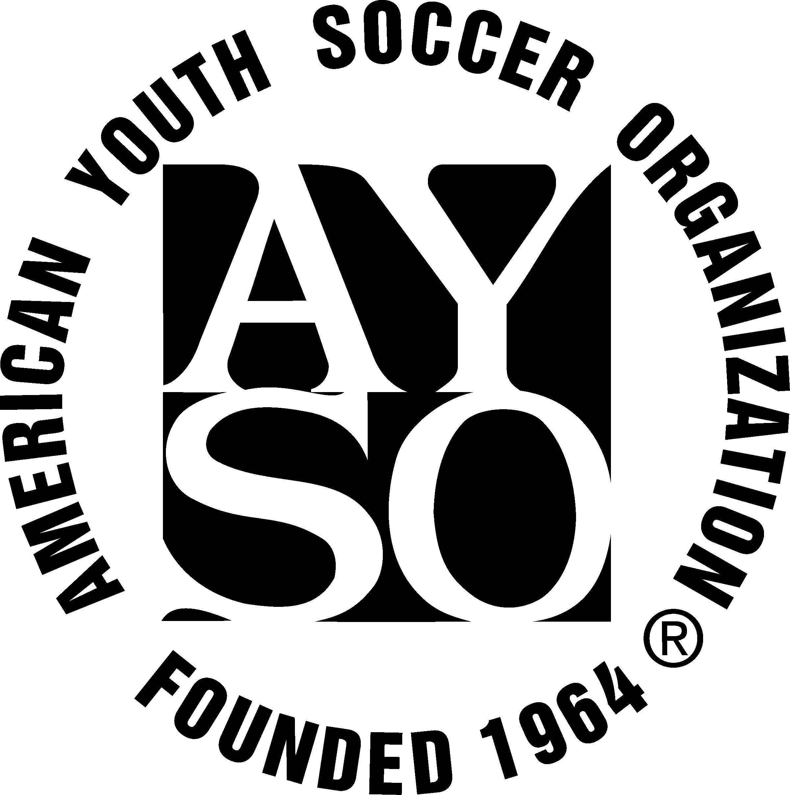 |  | American Youth Soccer Organization  Tournament Safety Plan Form
Tournament Name: |  |  |  |  | Safety Director Name:
Tournament Size  (number of teams) |  |  |  |  |  | Tournament Sites  (how many sites)
Tournament Safety Director Signature: ________________________________________
Report: |  |  |  |  |  |  |  |  | Yes | No
1. Safe Haven |  |  |  | We will make sure all tournament staff members are properly registered as AYSO volunteers and trained for their jobs.
 |  |  |  | Before accepting coaches and referees to our tournament, we will make every effort to obtain certification from their Regional Commissioner that they are Safe-Haven certified.
 |  |  |  | We will ensure that Safe-Haven plans for player send-offs are implemented.
 |  |  |  | We will make every effort to create a safe environment for our players as they attend our tournament.
2. First Aid: |  |  |  | We will be providing a trained volunteer at each location. The Tournament will supply the first aid material and equipment.
And/Or; |  |  |  | We will be using a medical EMT service to cover each of our tournament locations. They will furnish all the first aid material and equipment.
3. Player Registration Forms/Emergency Authorization: |  |  |  | At team check-in Player Registration Forms with Emergency Authorizations will be checked. Each player must have a current form with an original signature or they will not be allowed to participate.
4. Hospitals and Medical Centers |  |  |  | We will attempt to confirm that Player Registration Forms with Emergency Authorizations will be accepted at all of the local hospitals and medical centers. We will have maps and driving directions available at each first aid or EMT station.
5. Emergency Procedures |  |  |  | We will have emergency access to the playing fields at all locations for paramedics and ambulances. The tournament has a procedure on who will be making the emergency calls and how. These procedures will be communicated to the teams through mailings and this information will also be detailed to the teams at check in.
 |  |  |  | In large tournaments, we will have a plan to use cell phones and/or radios for communications between sites and/or between the fields and the Safety Director.
6. Liability and Incident Insurance Forms |  |  |  | We will have copies of Liability Insurance Certificates, Incident/ accident/SAI forms available at the tournament headquarters.
7. State Requirements |  |  |  | We will make every effort to assure compliance with all reasonable state and local requirements covering our tournament (some states require defibrillators and other types of equipment at large events). We will have in place emergency evacuation procedures if required by state law, local ordinances or facility use requirements. We will have in place all required health permits and vendor permits for the sale of food and merchandise.
8. Fields and Equipment |  |  |  | All fields, goals and nets will be inspected prior to the tournament to ensure they are safe for use. We will have adequate parking and restrooms available.

